Validate Attachments

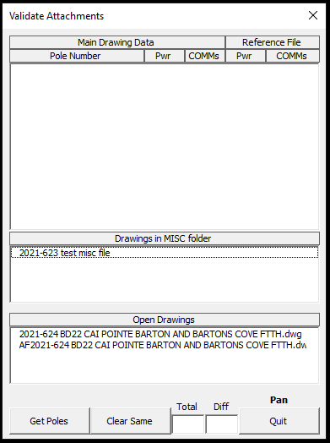

Note: it is much quicker to have the As Fielded file open before running the program. The other option is having the As Fielded file in the MISC folder withing the Main file folder.

Click on Get Poles to select the sPole blocks to validate. It will only keep the sPoles that have a pole number other than POLE. If the number is blank, it will be omitted from the list. The list shows the pole number, number of power attachments, and number of COMM attachments. It also shows the number of poles in the list.

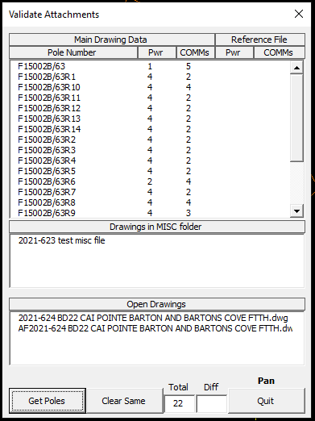

After this, double click on a file in the Drawings in Misc folder list or one in the Open Drawings list that is the As Fielded file. It matches the poles by the Lat,Long value.

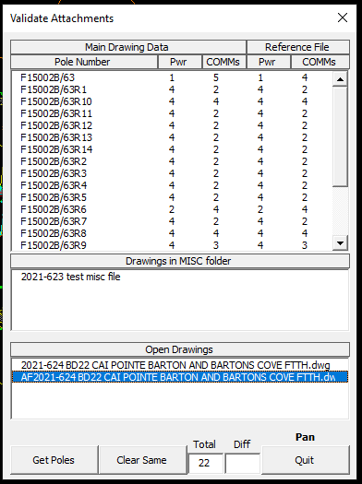

Click the Clear Same to remove the poles on the list when the number of power and COMM attachments are the same in both files.

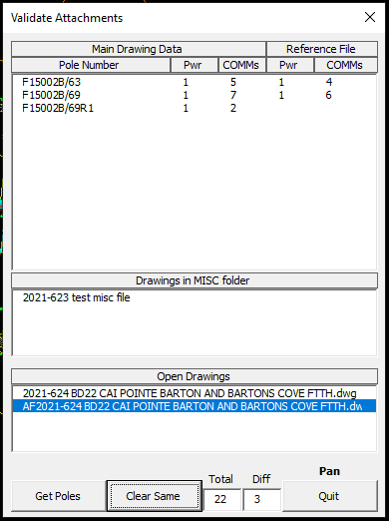

If you double click any pole in the list, it will zoom you in on the pole and display the attachments from the As Fielded file.

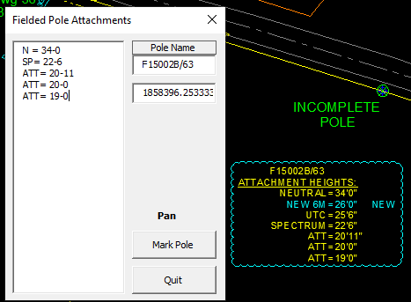

Click on Mark Pole if you want to put a large circle around the pole to look at later.

If you want to remove a pole from the list, click on the pole and hit the delete key.